Pt. BD SHARMA UNIVERSITY OF HEALTH SCIENCES, ROHTAK

VISUAL GUIDE – STEPS to FOLLOW

Stages of Applying for the Post
Post Apply
Print Out
Online Fee Payment

No Application Shall be considered as Complete if the prescribed fee is not paid for the post applied.
Registration
Profile
Completion

Visit www.uhsr.ac.in for latest information

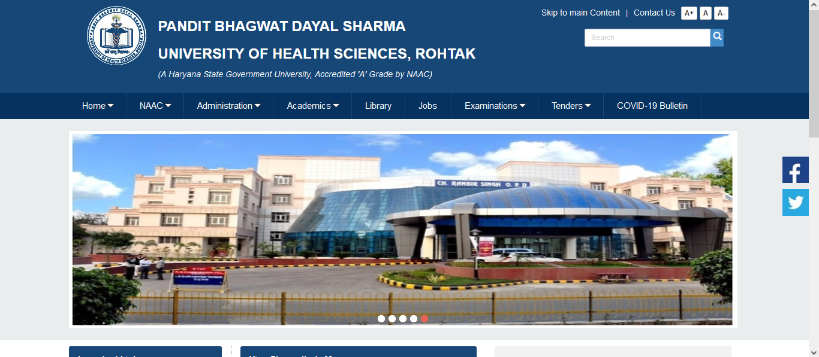
Visit https://nonteaching2021.uhsrohtak.in to apply for the post
Click Register
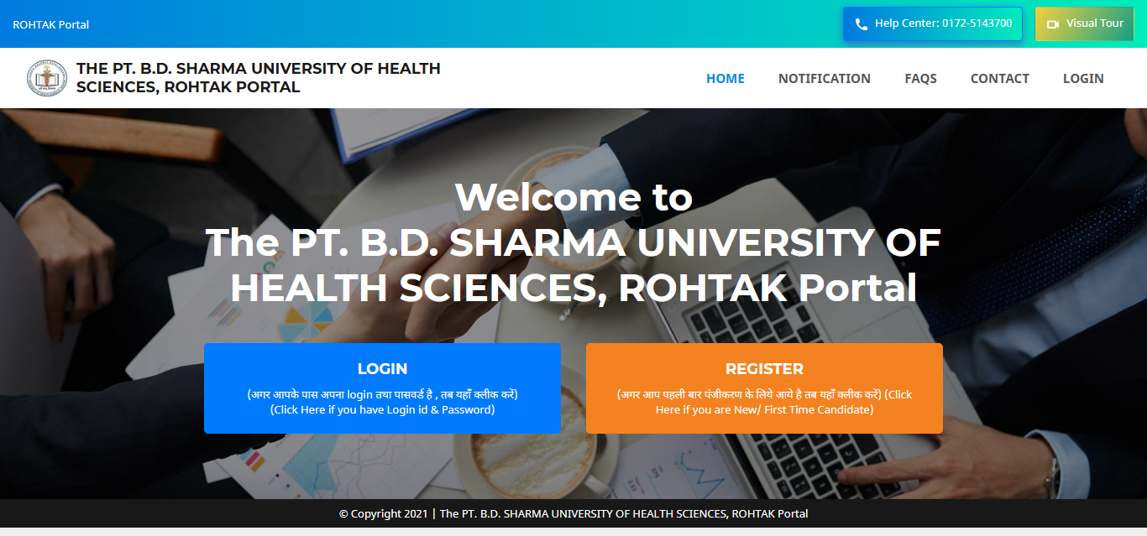

Read all details given on the left side links carefully then click on Continue to Registration

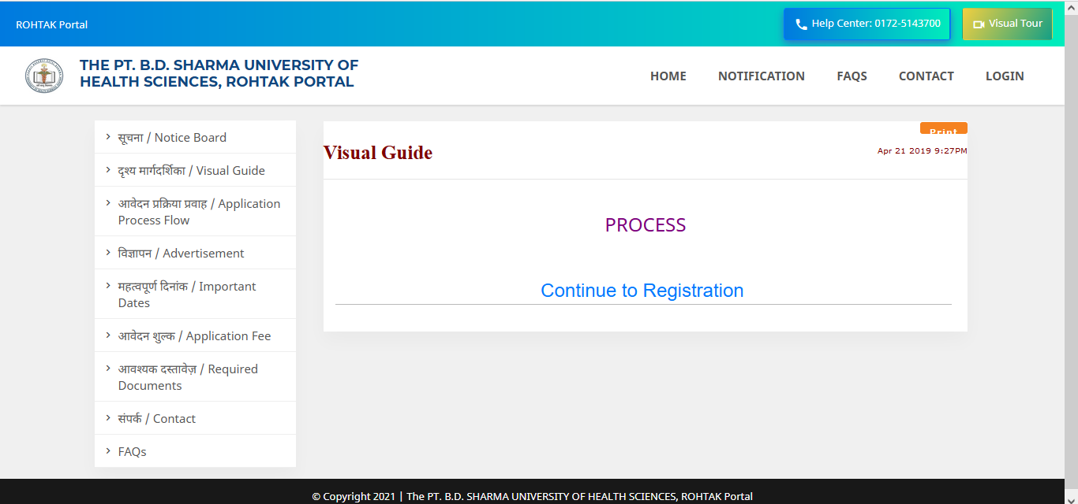

Registration page
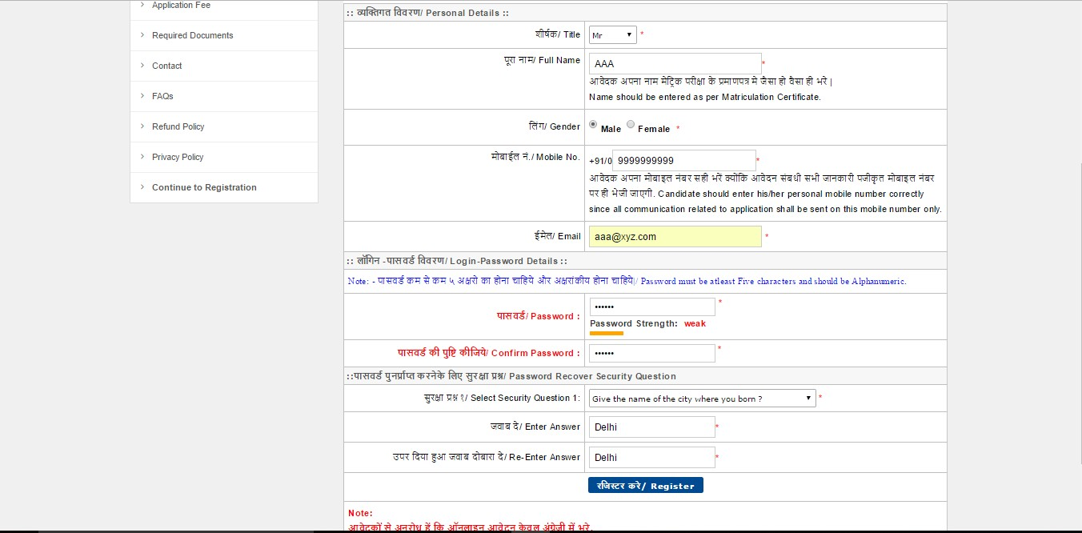

Click Here
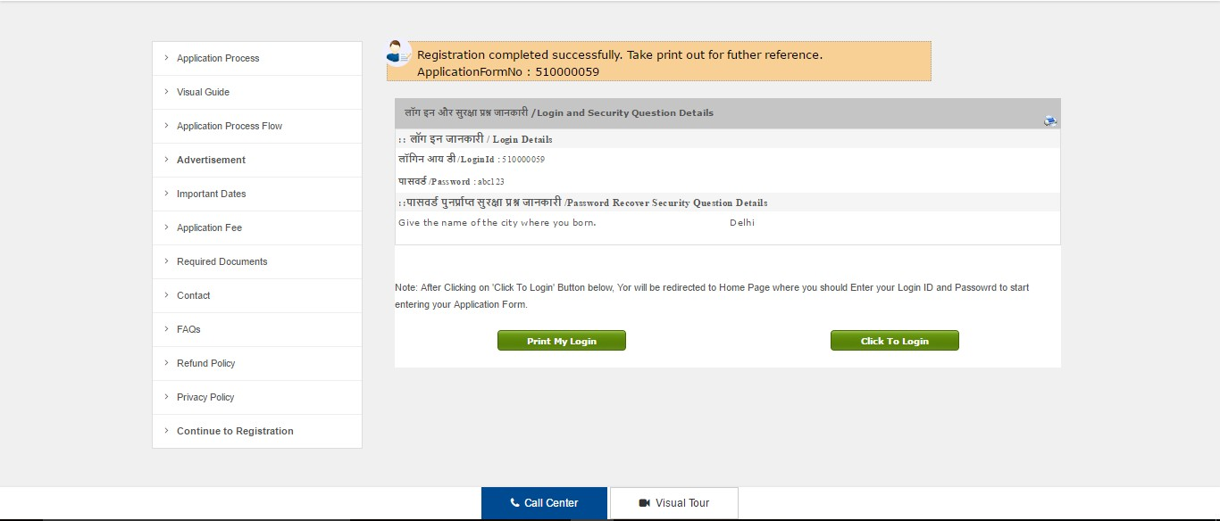After entering OTP received on registered mobile, preserve the print-out having details of your Login ID, password, security question for future reference.

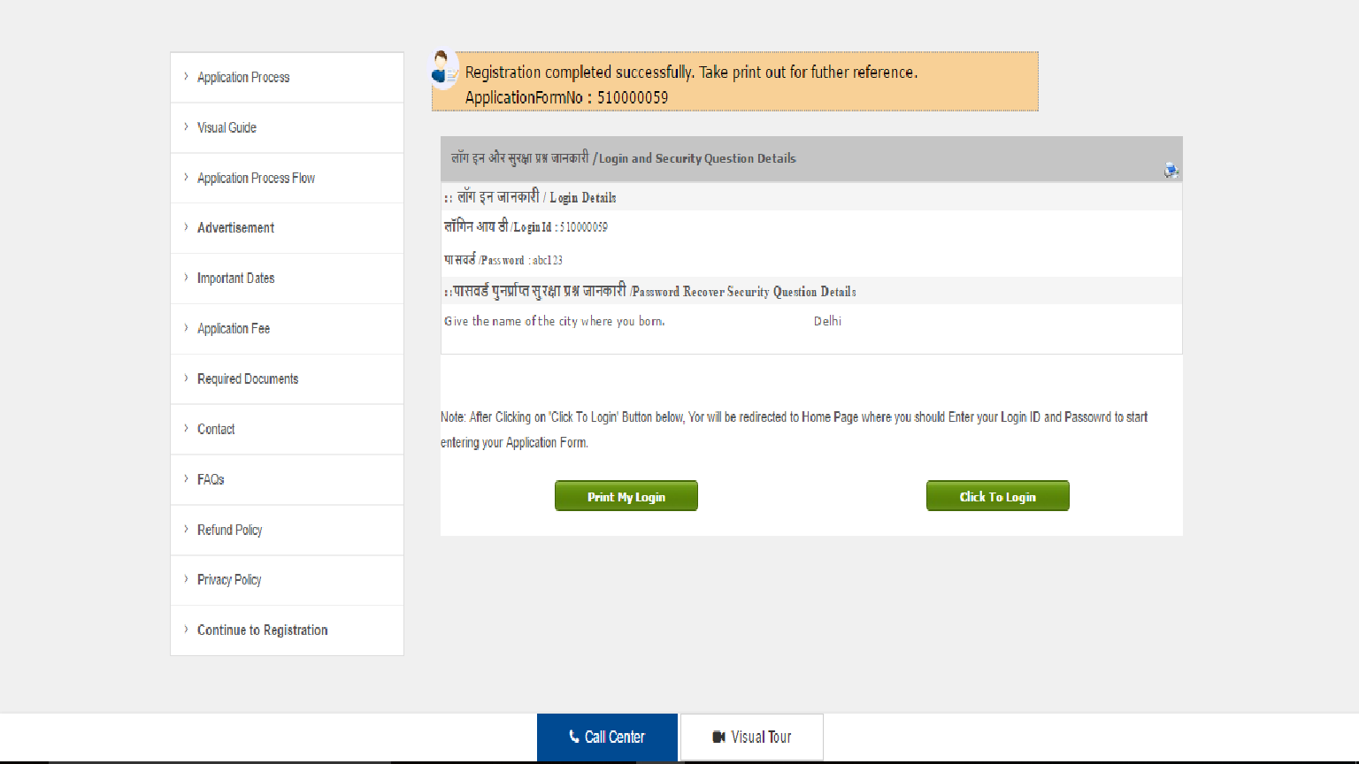

Click Here

Login here with your Login-id & Password
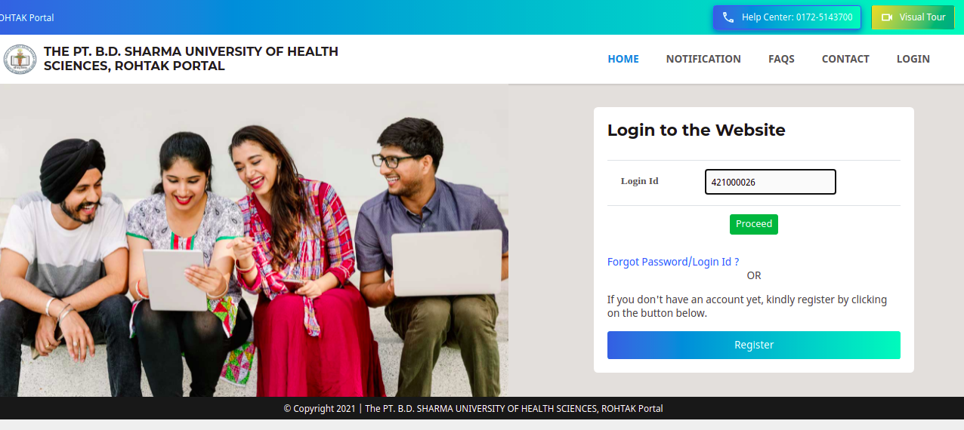
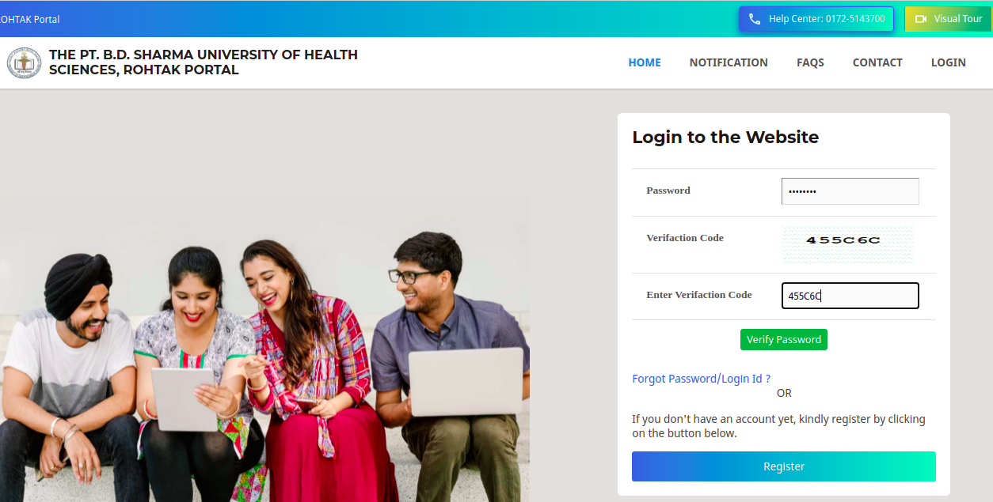

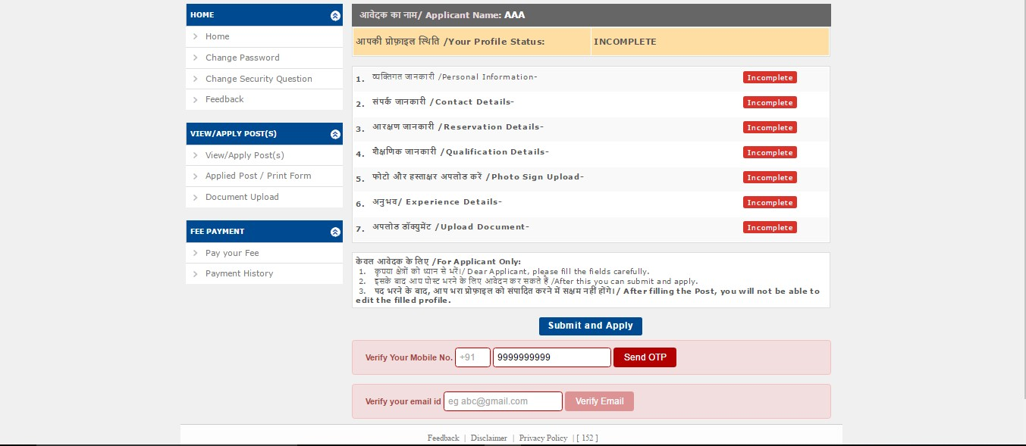Fill in all your information step-by-step

Start Filling the Information One by One

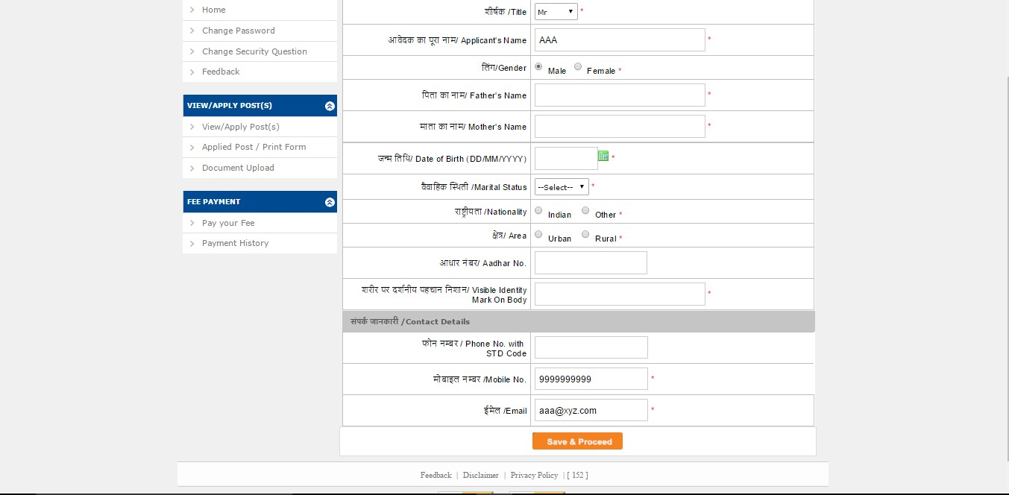
Fill in Personal Information & Contact details

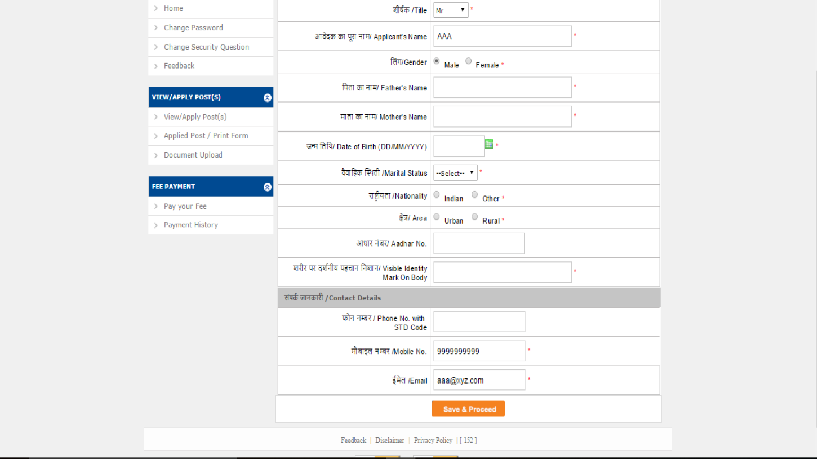

Click on save & proceed

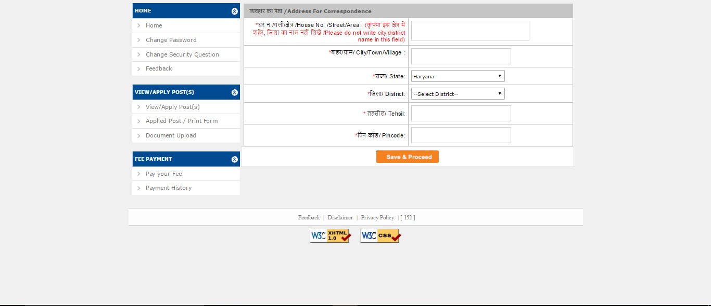Fill in your correspondence address details

Click here to save
& proceed

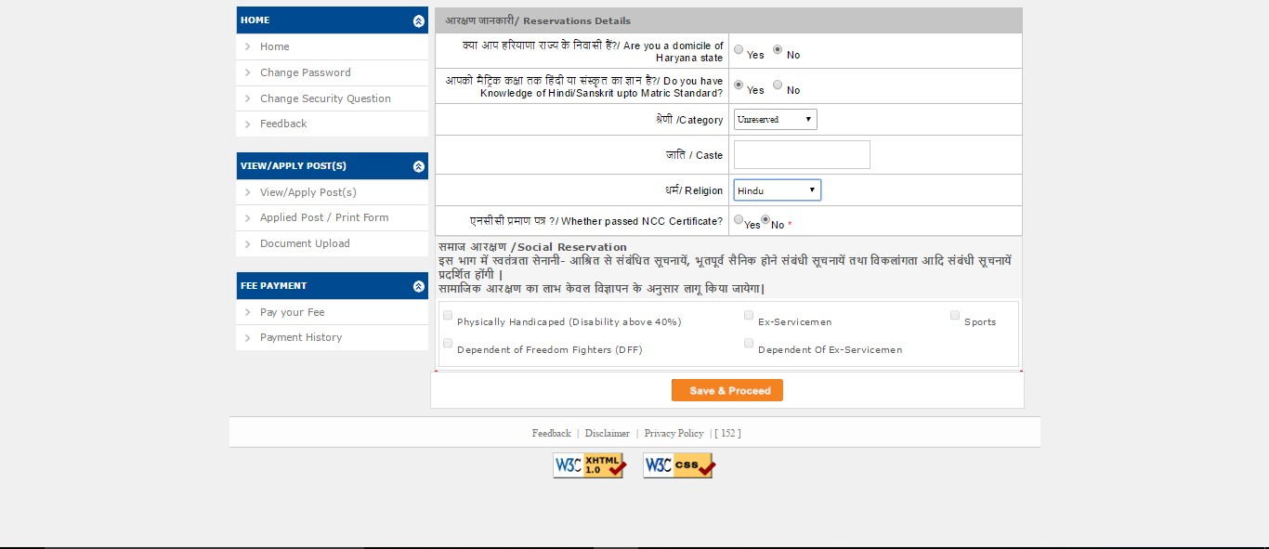Only those having domicile of Haryana reservation can claim reservation benefits, as applicable

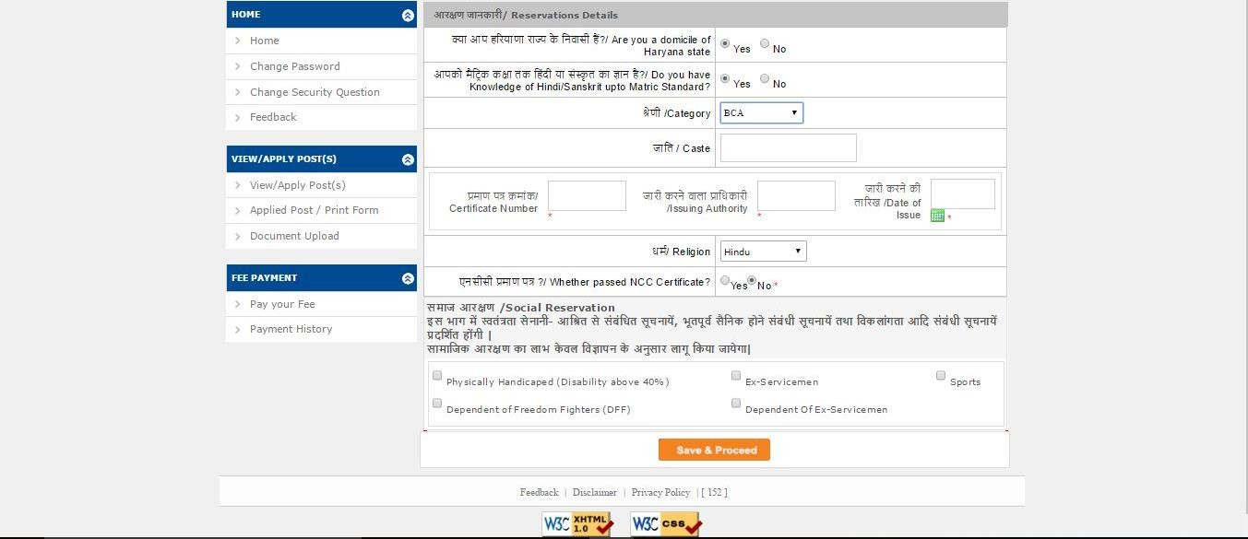If candidate belongs to Reserved category, please provide the Certificate Number, Issuing Authority, Date of Issue

Click Here to Save & Proceed

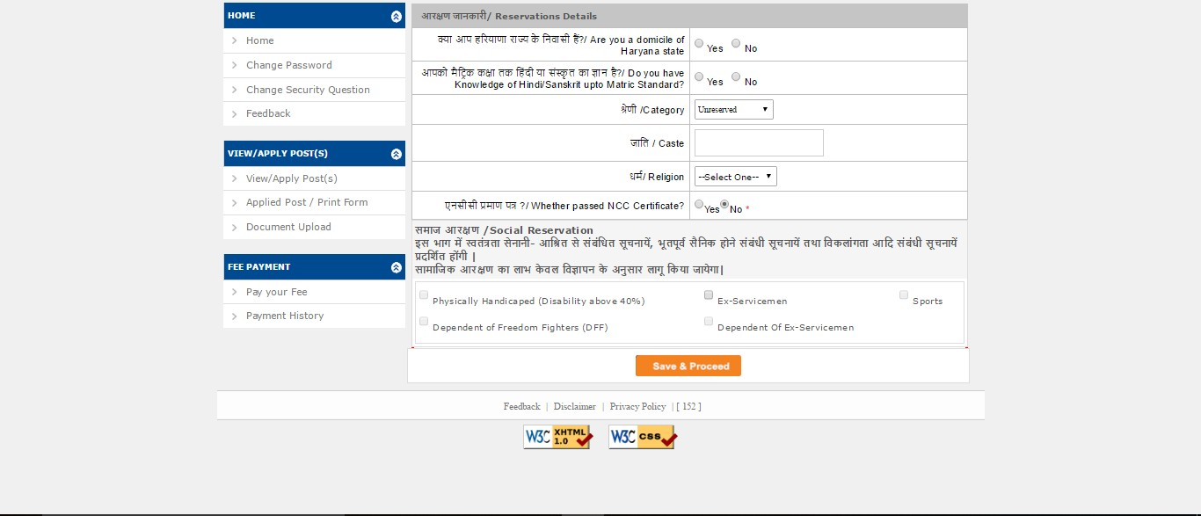Mention all the reservation / socio-economic criteria details carefully, as applicable

Click Here to Save & Proceed

Fill all the details regarding qualification.

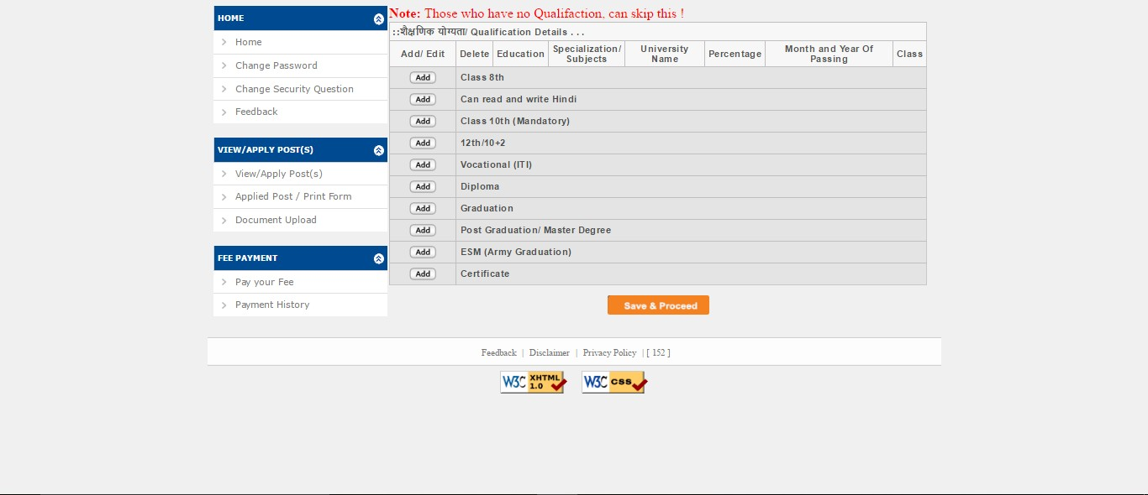

Click Here

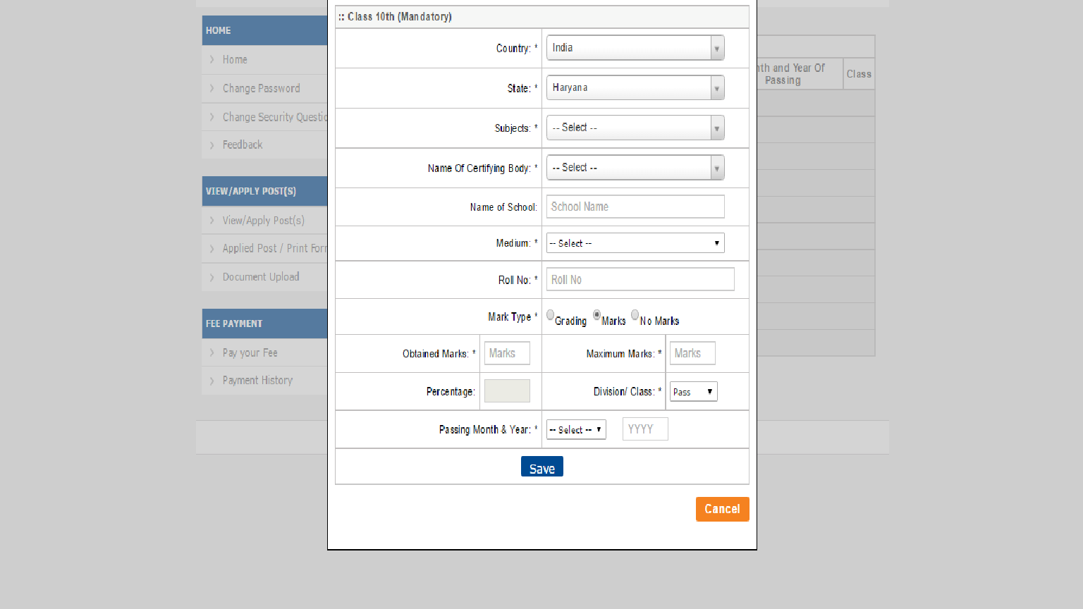

Click on Add button to add more Qualification

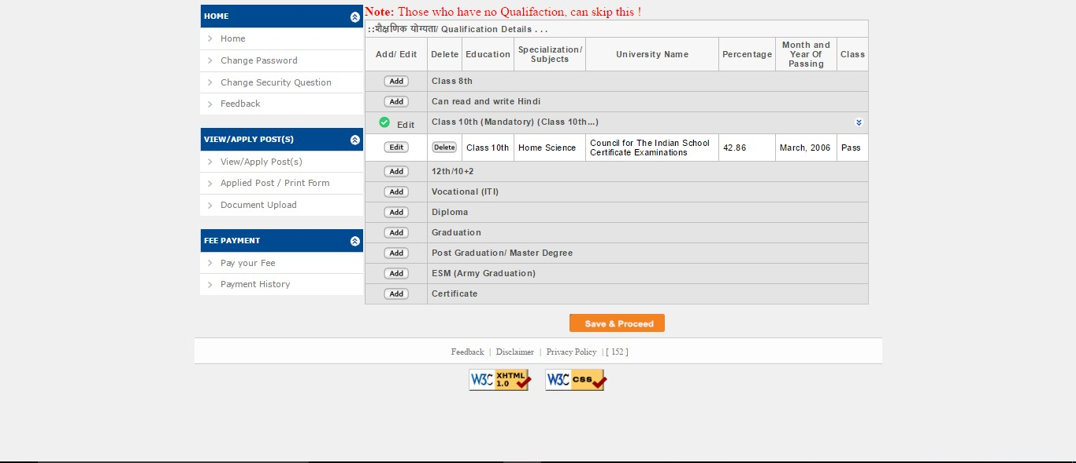

Click Here

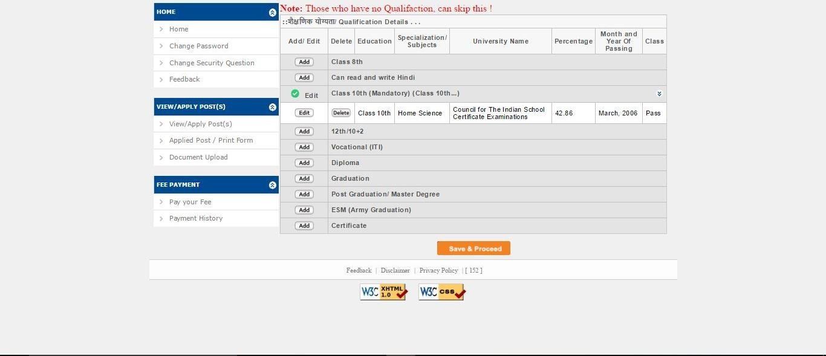After adding qualifications, click on Save & Proceed

Click Here to Save & Proceed

Photo & Signature size must be as per specified dimensions

Click here to browse photos
Click here to browse Signatures

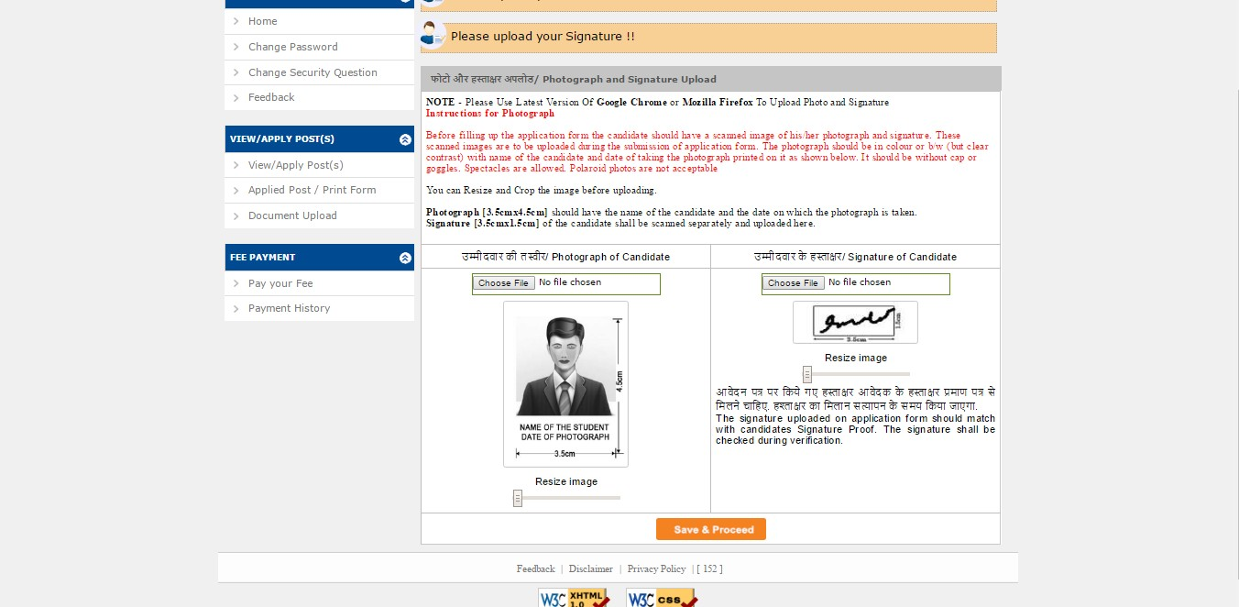

Click Here to Save & Proceed

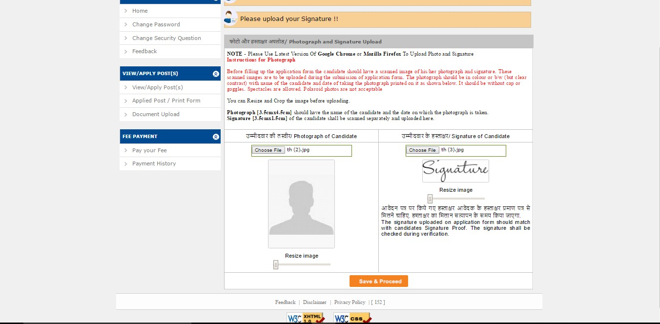After uploading photograph & signature, click on Save and Proceed

Click Here to Save &
Proceed

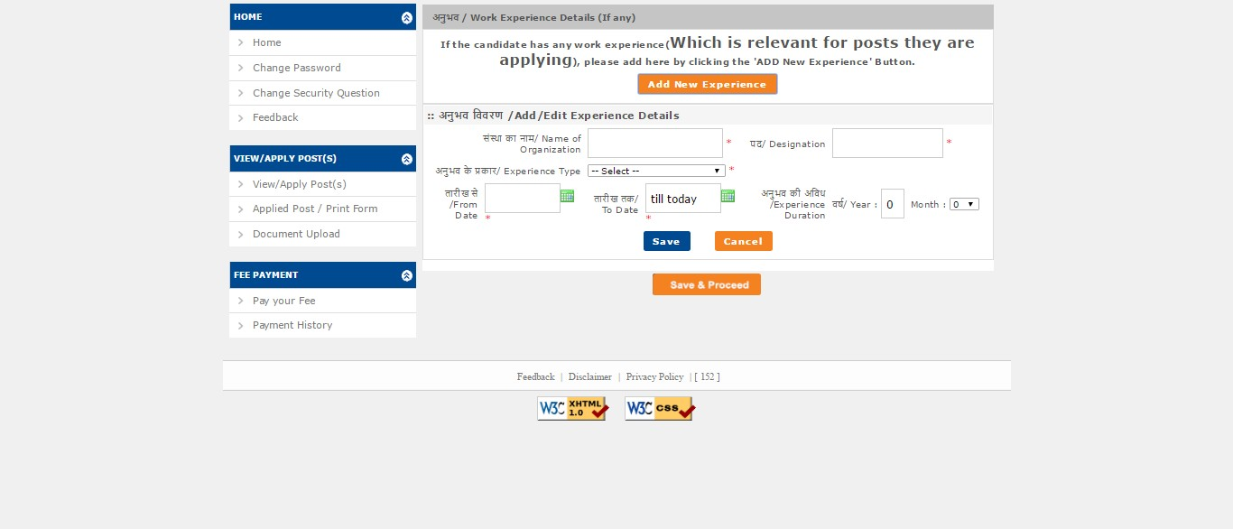Add experience according to eligibility

Click Here to Save &
Proceed

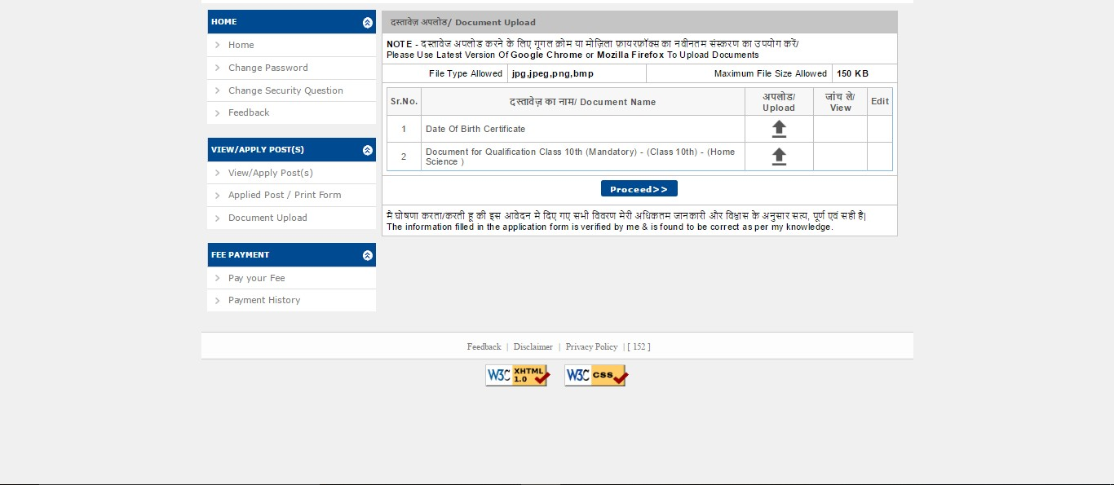Upload the relevant documents

Click to browse

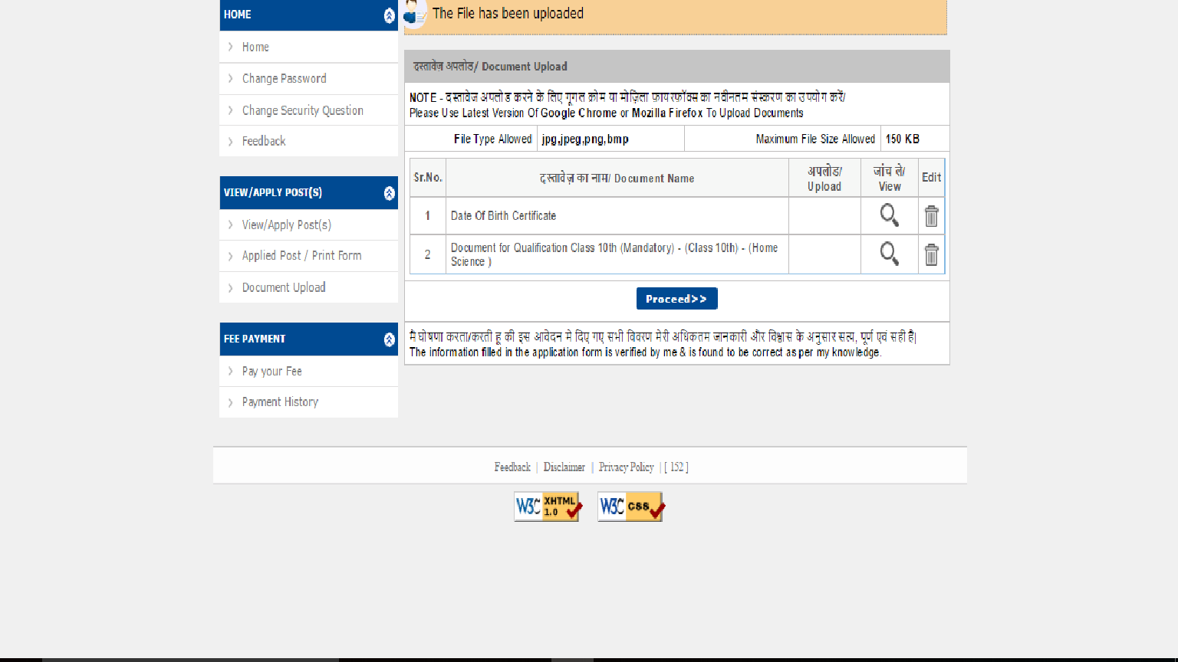

Click Here to Save & Proceed

After ensuring that all sections are Complete, click on View Profile

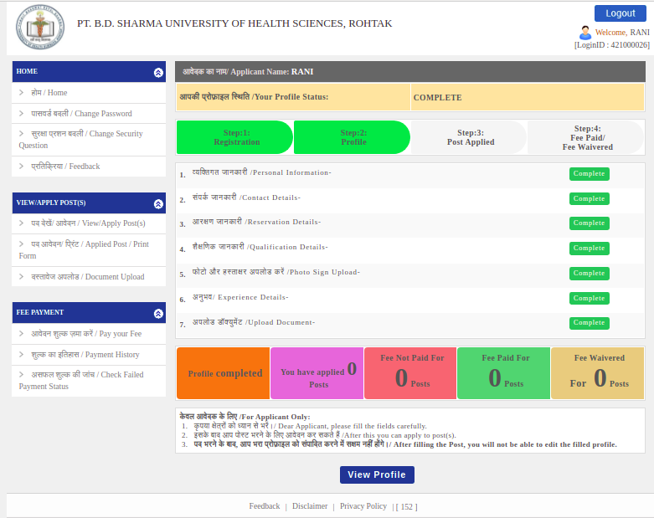
View Your Application Profile and take printout
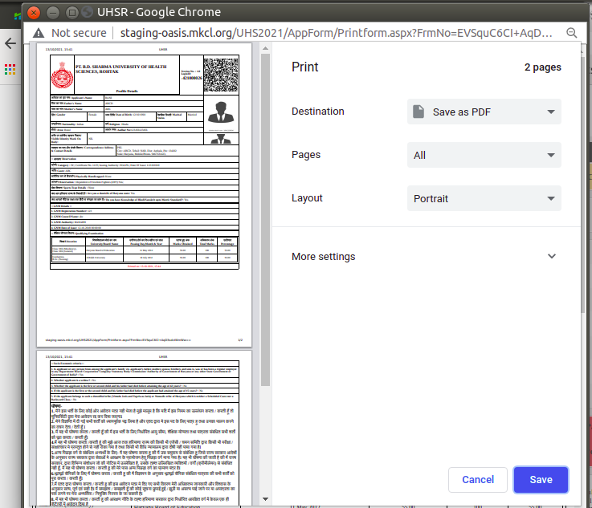
Application Profile Print PDF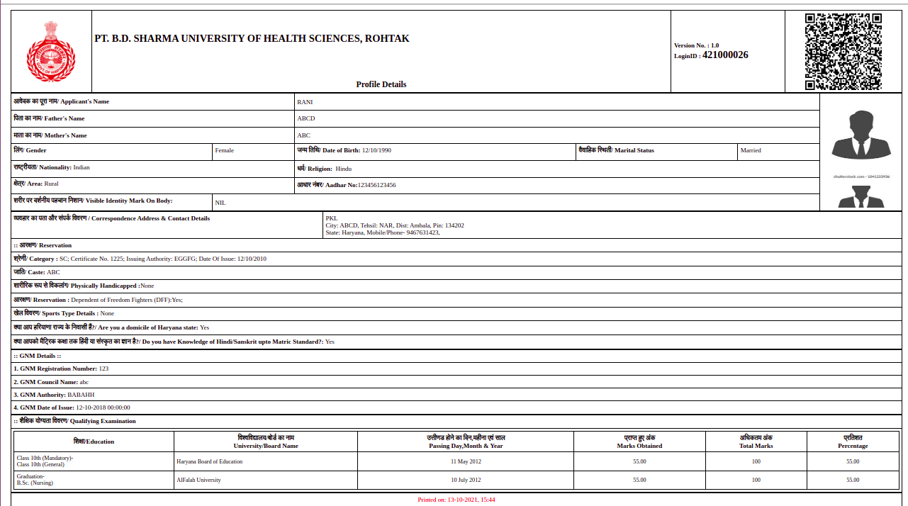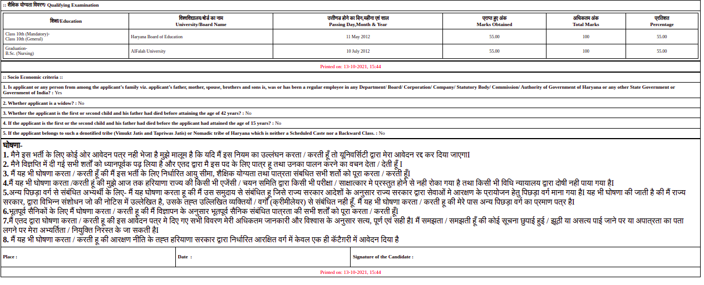

Click on Print Declaration and sign the printed declaration
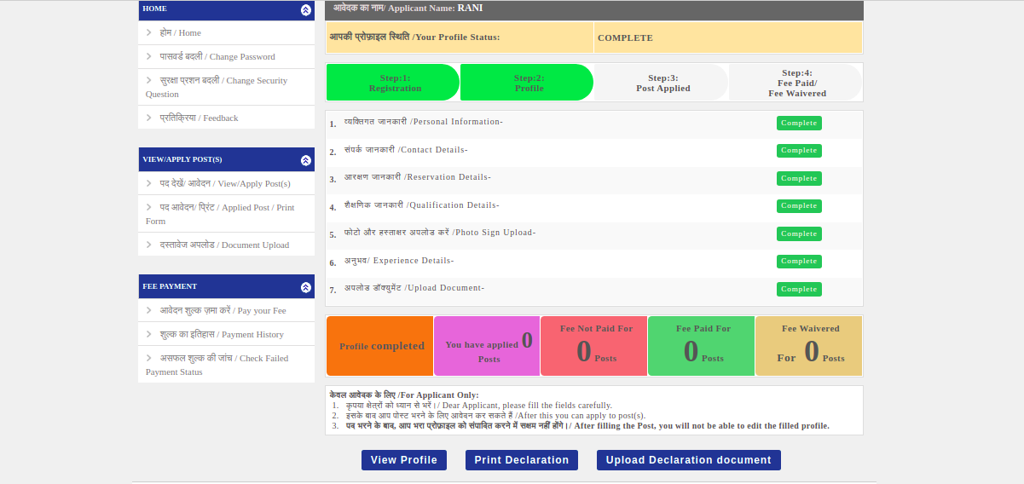
Declaration Certificate PDF
After signing the Declaration, scan and upload
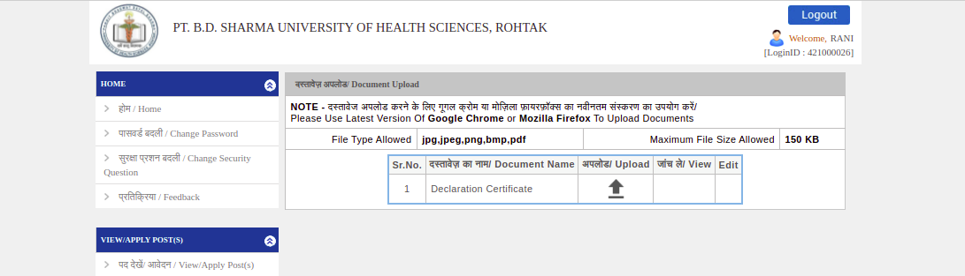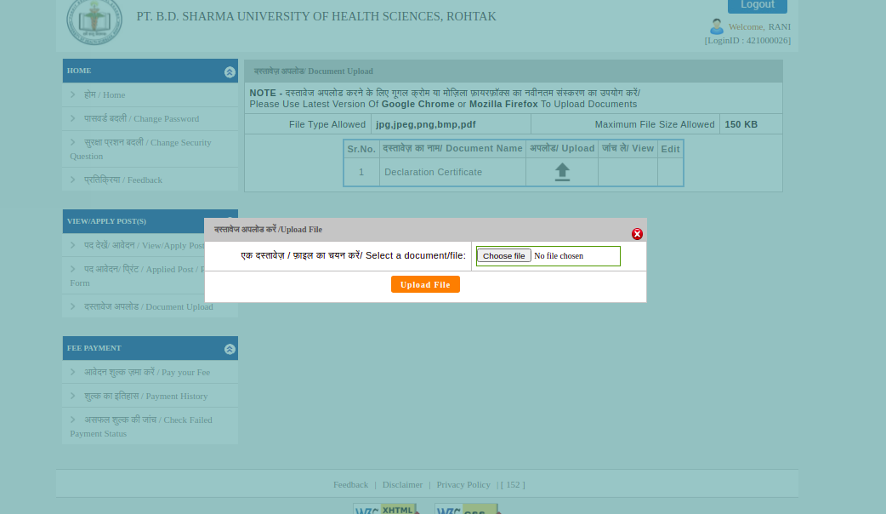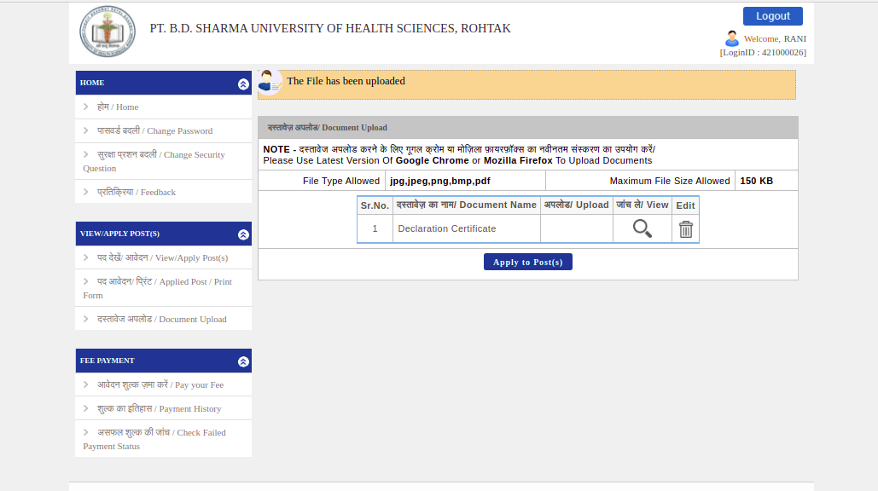

After successfully uploading the Declaration, click on Apply, and then on OK
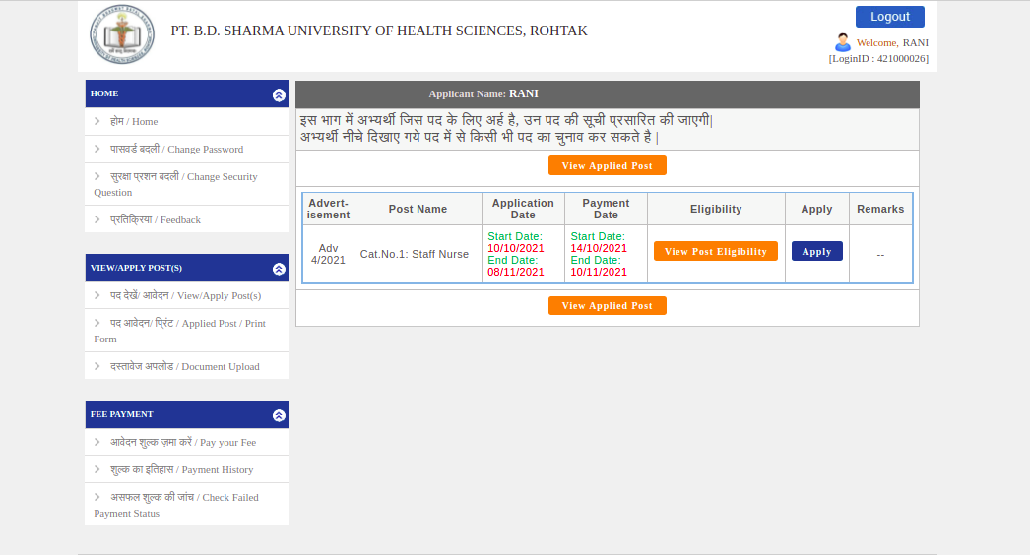

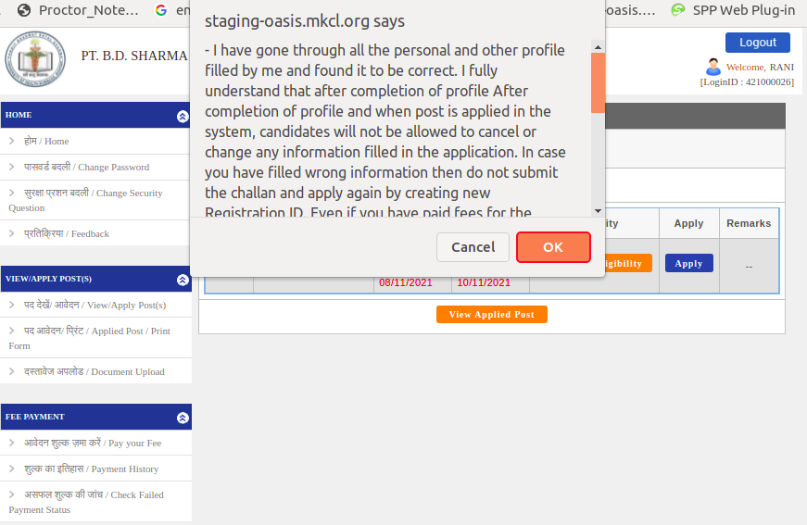

Click on OK and go to left side menu > Pay your Fee
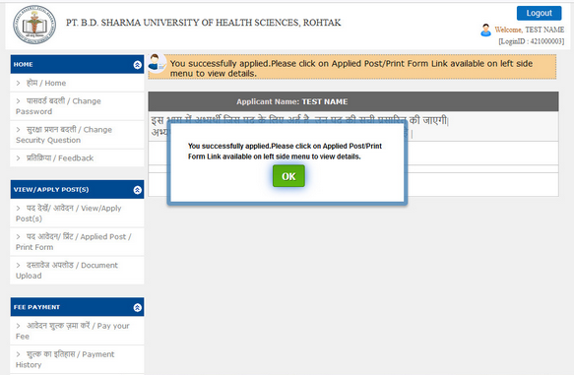

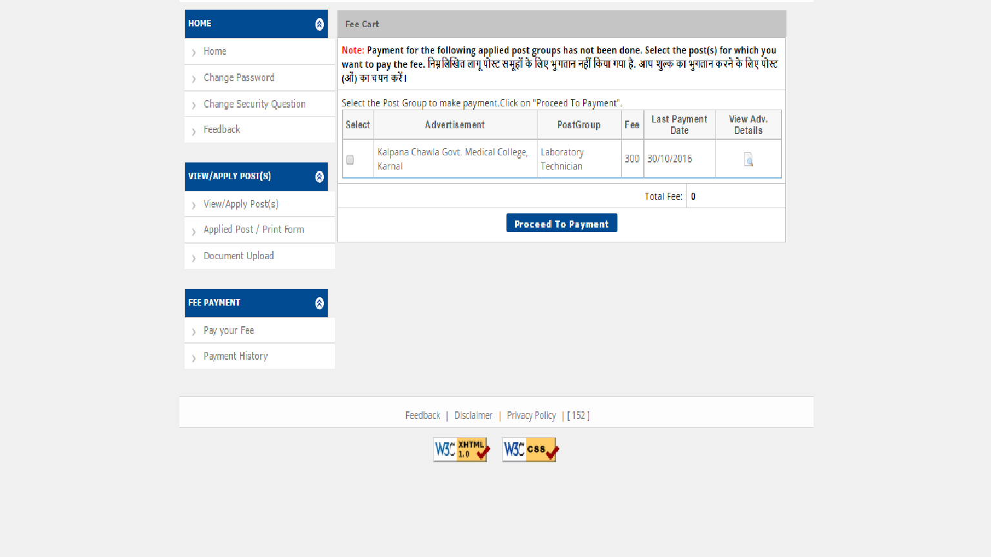

Check the box

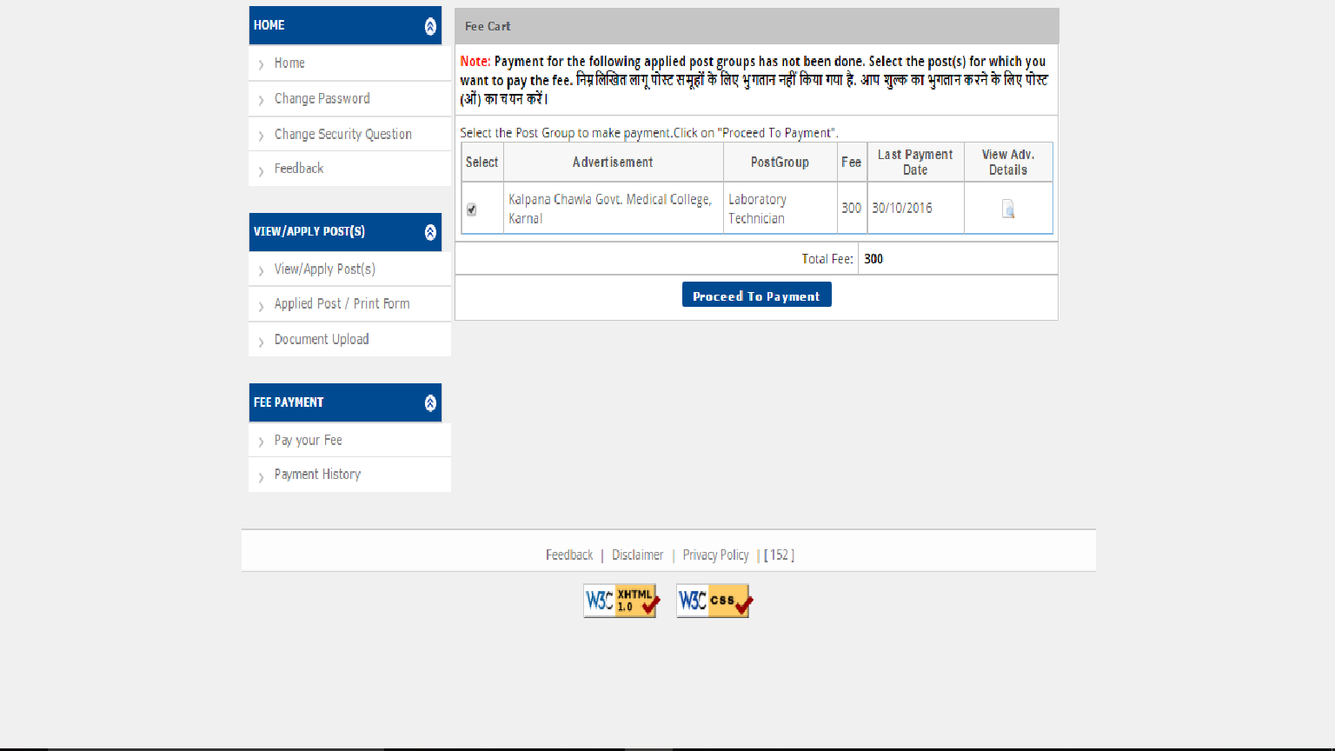

Click to make payment

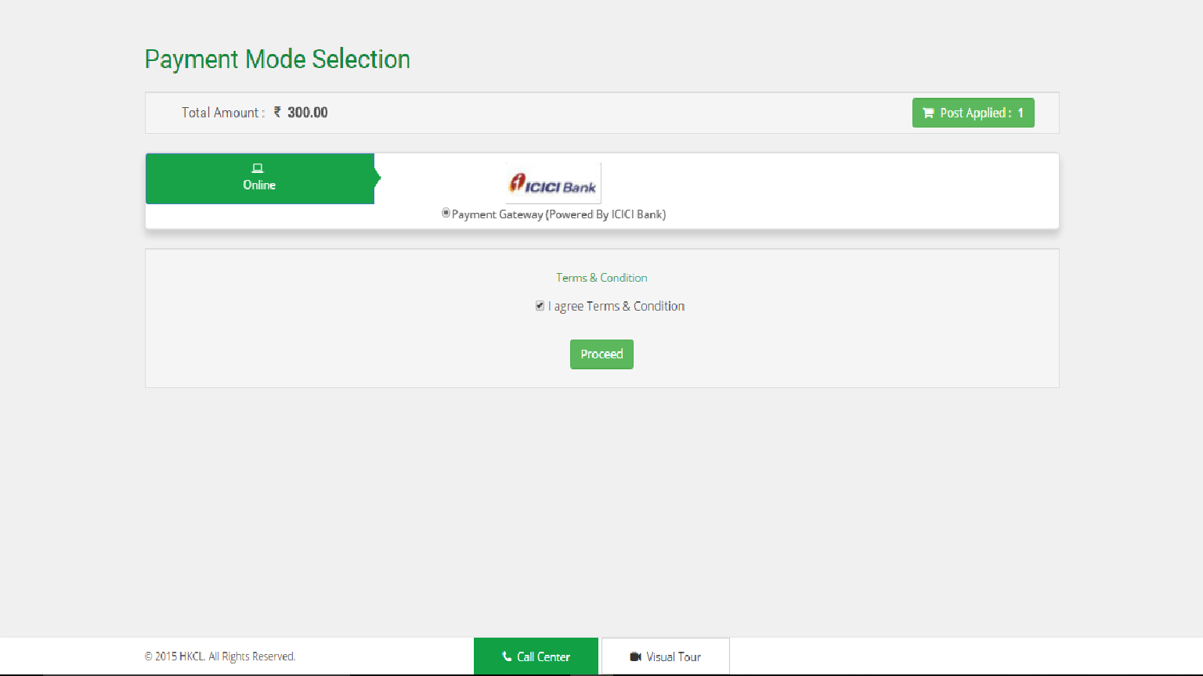

Check in the box

Check in the box
Click to proceed

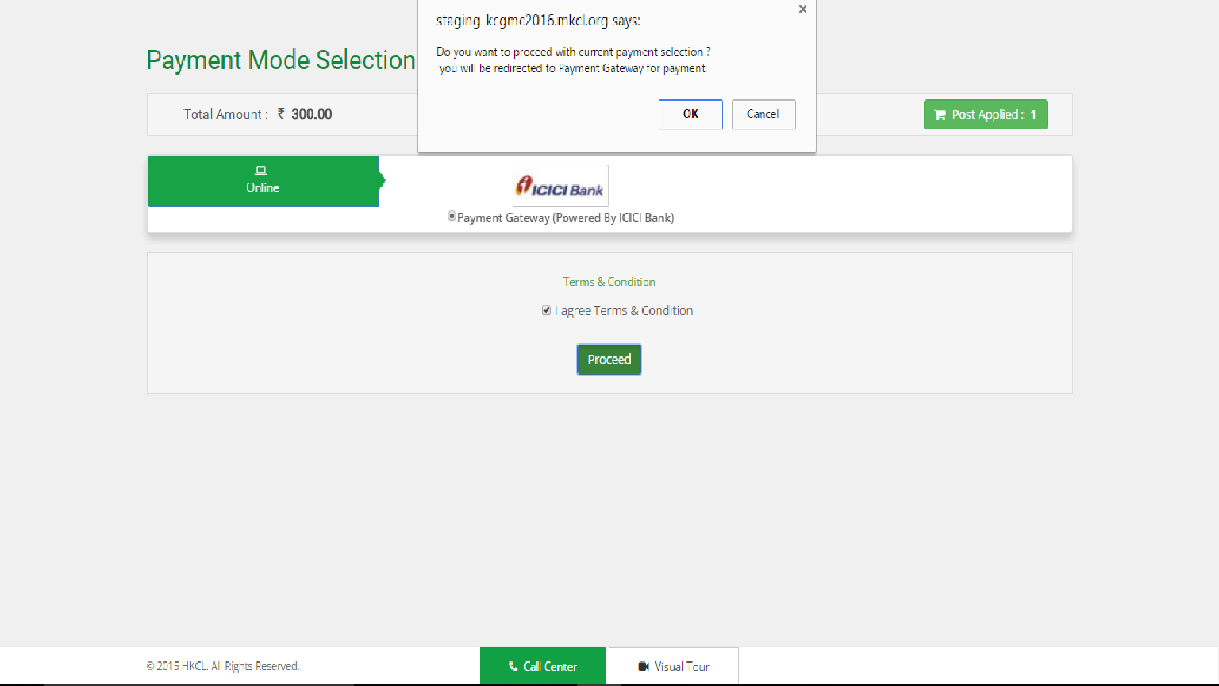
Click ok to proceed

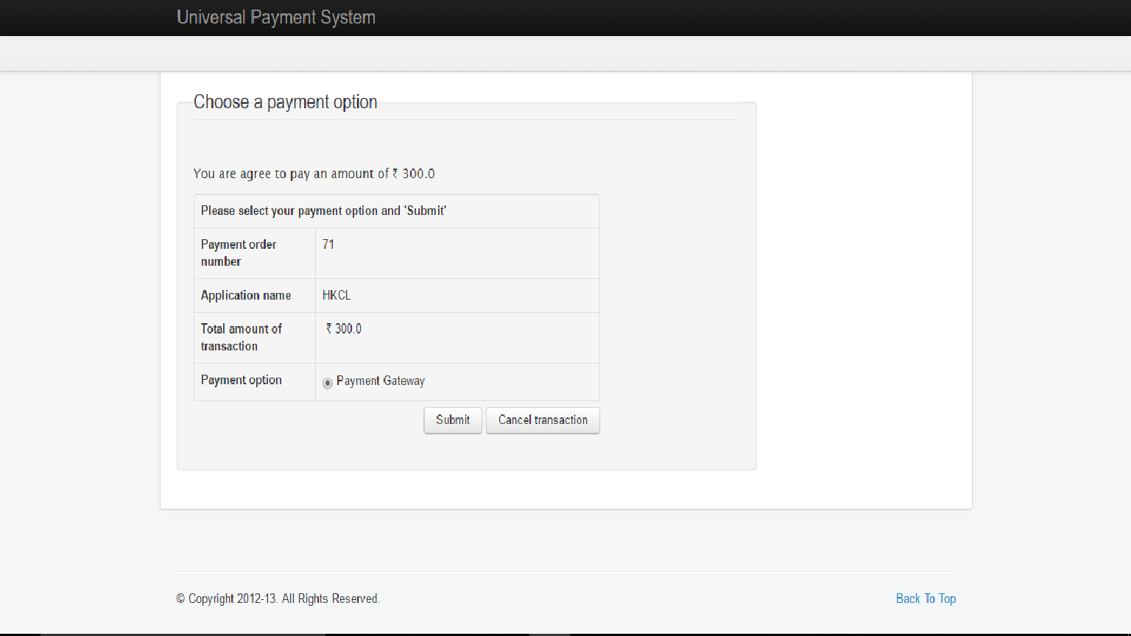

Check into box

Press

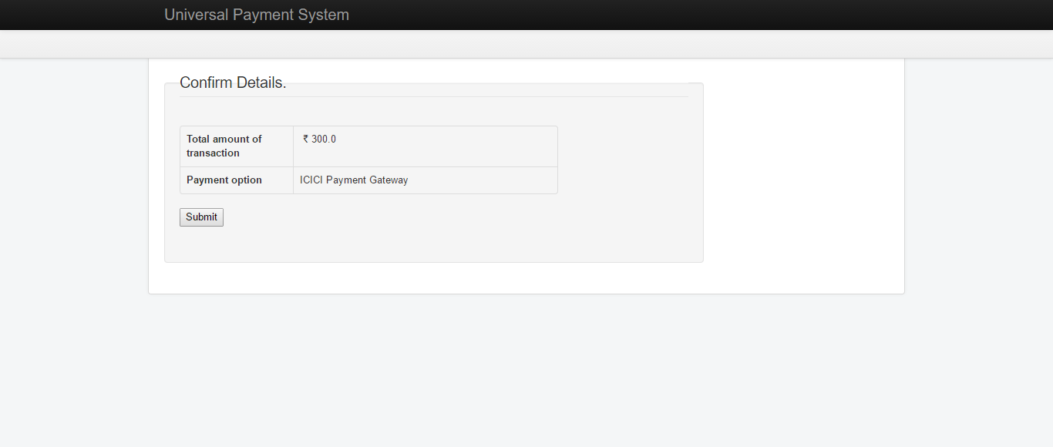

Click submit

Print out and safely retain the Detailed Payment Receipt
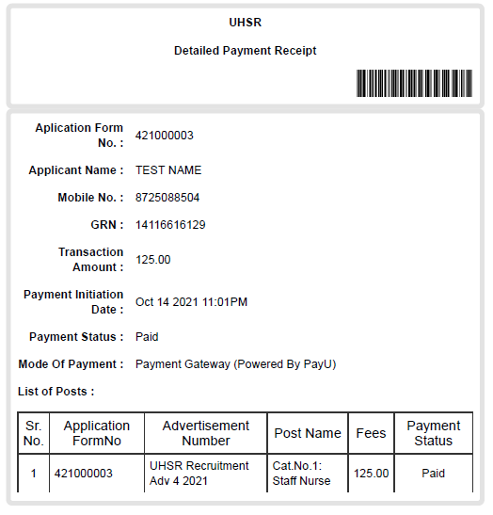

- MAKE ONLINE PAYMENT OF APPLICATION
FEES.
  - WAIT FOR 1 DAY FOR PAYMENT
CONFIRMATION IF PAYMENT IS NOT RECONCILED.
- TAKE THE PRINT-OUT OF APPLICATION FORM.

ALL THE BEST!!!

