Course: SBI PO Pre

Subject: Quadratic Inequalities

Time:10 Minutes
Published Date: 14th June 2020

Directions (1-15): In the following two equations questions numbered (I) and (II) are given. You have to solve both equations and Give answer

Q1. 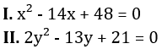
(a) If x > y
(b) If x ≥ y
(c) If y > x
(d) If y ≥ x
(e) If x = y or no relation can be established
L1Difficulty 2
QTags Quadratic Inequalities
QCreator Deepak Rohilla

Q2. 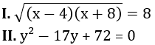
(a) If x > y
(b) If x ≥ y
(c) If y > x
(d) If y ≥ x
(e) If x = y or no relation can be established
L1Difficulty 2
QTags Quadratic Inequalities
QCreator Deepak Rohilla

Q3. 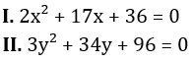
(a) If x > y
(b) If x ≥ y
(c) If y > x
(d) If y ≥ x
(e) If x = y or no relation can be established
L1Difficulty 2
QTags Quadratic Inequalities
QCreator Deepak Rohilla

Q4. 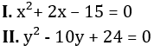
(a) If x > y
(b) If x ≥ y
(c) If y > x
(d) If y ≥ x
(e) If x = y or no relation can be established
L1Difficulty 2
QTags Quadratic Inequalities
QCreator Deepak Rohilla

Q5. 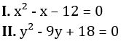
(a) If x > y
(b) If x ≥ y
(c) If y > x
(d) If y ≥ x
(e) If x = y or no relation can be established
L1Difficulty 2
QTags Quadratic Inequalities
QCreator Deepak Rohilla

Q6. 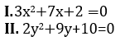
(a) if x > y
(b) if x ≥ y
(c) if x < y
(d) if x ≤ y
(e) if x = y or there is no relation between ‘x’ and ‘y’.
L1Difficulty 2
QTags Quadratic Inequalities
QCreator Deepak Rohilla

Q7. 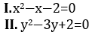
(a) if x > y
(b) if x ≥ y
(c) if x < y
(d) if x ≤ y
(e) if x = y or there is no relation between ‘x’ and ‘y’.
L1Difficulty 2
QTags Quadratic Inequalities
QCreator Deepak Rohilla

Q8. 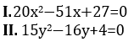
(a) if x > y
(b) if x ≥ y
(c) if x < y
(d) if x ≤ y
(e) if x = y or there is no relation between ‘x’ and ‘y’.
L1Difficulty 2
QTags Quadratic Inequalities
QCreator Deepak Rohilla

Q9. 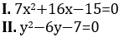
(a) if x > y
(b) if x ≥ y
(c) if x < y
(d) if x ≤ y
(e) if x = y or there is no relation between ‘x’ and ‘y’.
L1Difficulty 2
QTags Quadratic Inequalities
QCreator Deepak Rohilla

Q10. 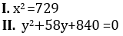
(a) if x > y
(b) if x ≥ y
(c) if x < y
(d) if x ≤ y
(e) if x = y or there is no relation between ‘x’ and ‘y’.
L1Difficulty 2
QTags Quadratic Inequalities
QCreator Deepak Rohilla

Q11. 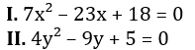
(a) if x > y
(b) if x ≥ y
(c) if y > x
(d) if y ≥ x
(e) if x = y or no relation can be established
L1Difficulty 2
QTags Quadratic Inequalities
QCreator Deepak Rohilla

Q12. 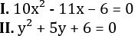
(a) if x > y
(b) if x ≥ y
(c) if y > x
(d) if y ≥ x
(e) if x = y or no relation can be established
L1Difficulty 2
QTags Quadratic Inequalities
QCreator Deepak Rohilla

Q13. 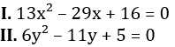
(a) if x > y
(b) if x ≥ y
(c) if y > x
(d) if y ≥ x
(e) if x = y or no relation can be established
L1Difficulty 2
QTags Quadratic Inequalities
QCreator Deepak Rohilla

Q14. 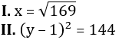
(a) if x > y
(b) if x ≥ y
(c) if y > x
(d) if y ≥ x
(e) if x = y or no relation can be established
L1Difficulty 2
QTags Quadratic Inequalities
QCreator Deepak Rohilla

Q15. 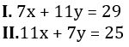
(a) if x > y
(b) if x ≥ y
(c) if y > x
(d) if y ≥ x
(e) if x = y or no relation can be established
L1Difficulty 2
QTags Quadratic Inequalities
QCreator Deepak Rohilla

Solutions

S1. Ans.(a)
Sol. 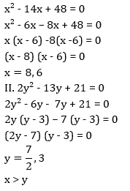

S2. Ans.(d)
Sol. 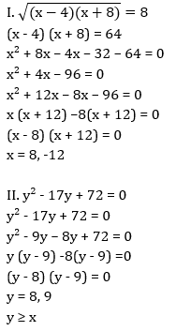

S3. Ans.(a)
Sol. 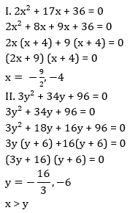

S4. Ans.(c)
Sol. 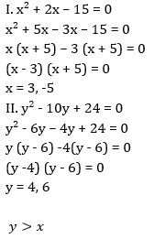

S5. Ans.(e)
Sol. 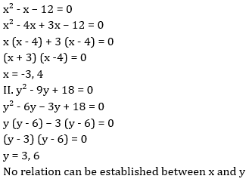

S6. Ans.(b)
Sol. 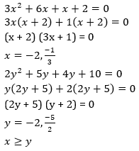

S7. Ans.(e)
Sol. 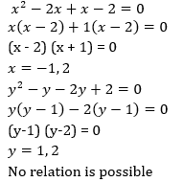

S8. Ans.(a)
Sol. 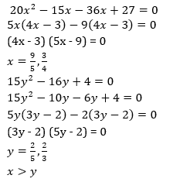

S9. Ans.(e)
Sol. 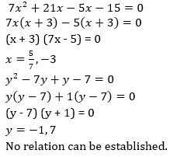.

S10. Ans.(a)
Sol.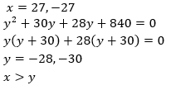

S11. Ans.(a)
Sol. 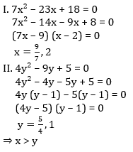

S12. Ans.(a)
Sol. 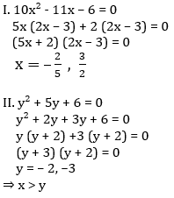

S13. Ans.(b)
Sol. 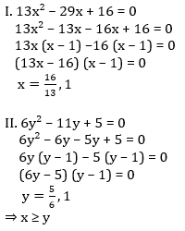

S14. Ans.(b)
Sol. 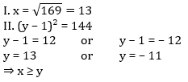

S15. Ans.(c)
Sol. 