Course: IBPS RRB Prelims

Subject: Percentage, Ratio & Proportion, Number System

Time:10 Minutes
Published Date: 7th August 2020

Q1. In a class 60% of the students pass in Hindi and 45% pass in Sanskrit. If 25% of them pass in both subjects, what percentage of the students fail in both the subjects?
(a) 80%
(b) 75%
(c) 20%
(d) 25%
(e) 30%
L1Difficulty 2
QTags Percentage
QCreator Deepak Rohilla

Q2. The ratio of the number of boys to that of girls in a school is 4 : 1. If 75% of boys and 70% of the girls are scholarship holders, then the percentage of students who do not get scholarship is :
(a) 50%
(b) 28%
(c) 75%
(d) 26%
(e) 36%
L1Difficulty 2
QTags Percentage
QCreator Deepak Rohilla

Q3. The strength of a school increases and decreases in every alternate year by 10%. It started in 2000 and increases in 2001, then the strength of the school in 2003 as compared to that in 2000 was:
(a) increased by 8.9%
(b) decreased by 8.9%
(c) increased by 9.8%
(d) decreased by 9.8%
(e) increase by 7.8%
L1Difficulty 2
QTags Ratio And Proportion
QCreator Deepak Rohilla

Q4. A spider climbed 62 ½ % of the height of the pole in one hour and in the next hour it covered 12 ½ % of the remaining height. If pole’s height is 192 m, then the distance climbed in second hour is
(a) 3 m
(b) 5 m
(c) 7 m
(d) 9 m
(e) 12 m
L1Difficulty 2
QTags Percentage
QCreator Deepak Rohilla

Q5. The red blood cells in a blood sample grows by 10% per hour in first two hours, decreases by 10% in next one hour, remains constant in next one hour and again increases by 5% per hour in next two hours. If the original count of the red blood cells in the sample is 40000, find the approximate red blood cell count at the end of 6 hours.
(a) 40000
(b) 45025
(c) 48025
(d) 50025
(e) 52025
L1Difficulty 2
QTags Percentage
QCreator Deepak Rohilla

Q6. In the university examination last year, Rajesh scored 65% in English and 82% in History. What is the minimum percent he should score in Sociology, which is out of 50 marks (if English and History were for 100 marks each), if he aims at getting 78% overall?
(a) 94%
(b) 92%
(c) 98%
(d) 96%
(e) 86%
L1Difficulty 2
QTags Percentage
QCreator Deepak Rohilla

Q7. In a market research project, 20% opted for Nirma detergent whereas 60% opted for Surf Blue detergent. The rest were unsure. If the difference between those who opted for Surf Blue and those who were uncertain is 720. How many people participated in the survey?
(a) 1800
(b) 1440
(c) 3600
(d) Data Inadequate
(e) None of these
L1Difficulty 2
QTags Percentage
QCreator Deepak Rohilla

Q8. Ram’s weight is 140% of Manu’s weight. Tanu’s weight is 90% of Mahesh’s weight. Mahesh’s weight is twice as much as Manu’s. What percentage of Ram’s weight is Tanu’s weight? (approximately)
(a) 64%
(b) 78%
(c) 90%
(d) 72%
(e) 68%
L1Difficulty 2
QTags Percentage
QCreator Deepak Rohilla

Q9. In an examination a student Raj got 25% of the maximum marks and failed by 15 marks. Another student Ravi scored 35% of the maximum marks which was 25 marks more than the passing marks. The necessary percentage required for passing is
(a) 32.75%
(b) 23.5%
(c) 28.75%
(d) 20%
(e) 27.85%
L1Difficulty 2
QTags Percentage
QCreator Deepak Rohilla

Q10. In 2015, ratio of the number of students taking examinations in x, y and z states are respectively 3 : 5 : 6. Next year, the number of students are increased by 20%, 10% and 20% respectively. If ratio of the number of students in states x and z is 1 : 2, then find the number of students who sit to take examination in 2015.
(a) 5000
(b) 6000
(c) 75000
(d) Data insufficient
(e) None of these
L1Difficulty 2
QTags Ratio And Proportion
QCreator Deepak Rohilla

Q11. Due to a 25% increase in the price of rice per kilogram, a person is able to purchase 20 kg less for Rs. 400. What is the increased price of rice per kilogram?
(a) Rs. 5
(b) Rs. 6
(c) Rs. 10
(d) Rs. 4
(e) Rs. 8
L1Difficulty 2
QTags Percentage
QCreator Deepak Rohilla

Q12. A sum of Rs. 6,192 is distributed among A, B and C, such that A receives 25% more than B and B receives 25% less than C. What is C’s share in the amount?
(a) Rs. 2,072
(b) Rs. 2,304
(c) Rs. 2,620
(d) Rs. 2,258
(e) Rs. 2,340
L1Difficulty 2
QTags Percentage
QCreator Deepak Rohilla

Q13. There are 1,10,000 books at khuda Baksh Oriental Public Library, 40% of total are Science books. It was decided to add 20,000 new books to the library. How many of the new books should be Science books in order to bring the percentage of Science books in the library equal to 45%?
(a) 15,000
(b) 1,500
(c) 1,450
(d) 14,500
(e) 15,500
L1Difficulty 2
QTags Percentage
QCreator Deepak Rohilla

Q14. The sum of money is to be divided amongst A, B and C in the respective ratio of 3 : 4 : 5 and another sum of money to be divided between E and F equally. If F got Rs. 1050 less than A, how much amount did B receive?
(a) Rs. 750
(b) Rs. 2000
(c) Rs. 1500
(d) Cannot be determined
(e) None of these
L1Difficulty 2
QTags Ratio And Proportion
QCreator Deepak Rohilla

Q15. On his deathbed, Mr. Kalu called upon his three sons and told them to distribute all his assets worth Rs. 525,000 in the ratio of 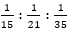 amongst themselves. Find the biggest share amongst the three portions.
(a) Rs. 17,5000
(b) Rs. 24,5000
(c) Rs. 10,5000
(d) Rs. 13,2500
(e) Rs. 12,3500
L1Difficulty 2
QTags Ratio And Proportion
QCreator Deepak Rohilla

Solutions

S1. Ans.(c)
Sol. 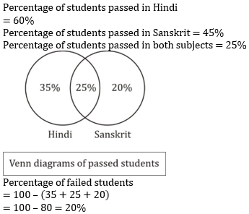

S2. Ans.(d)
Sol. 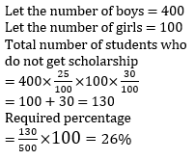

S3. Ans.(a)
Sol. 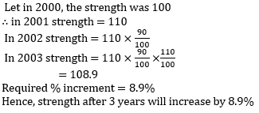

S4. Ans.(d)
Sol. 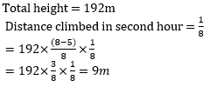

S5. Ans.(c)
Sol.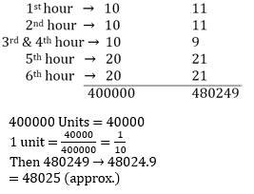

S6. Ans.(d)
Sol. 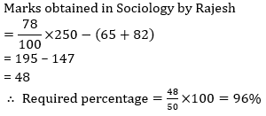

S7. Ans.(a)
Sol. Let total percentage of people who participated in survey = 100%
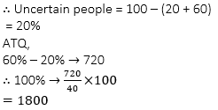

S8. Ans.(b)
Sol. 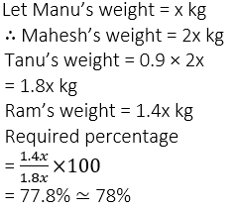

S9. Ans.(c)
Sol. 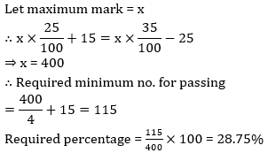

S10. Ans.(d)
Sol. 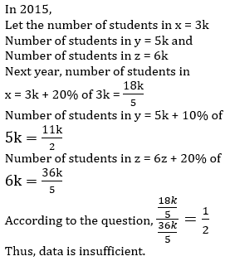

S11. Ans.(a)
Sol.
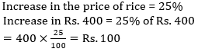
Increased price of rice per kg = 100/20 = 5rp

S12. Ans.(b)
Sol. 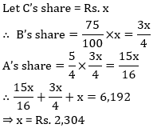

S13. Ans.(d)
Sol. 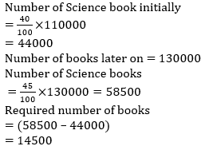

S14. Ans.(d)
Sol. Let total money divided among A, B and C is 12 x
∴ A’s part = 3x, B’s part = 4x and C’s part = 5x
∴ F’s part = 3x – 1050 = E’s part
Here we don’t know the second sum.
So, answer can’t be determined

S15. Ans.(b)
Sol. 