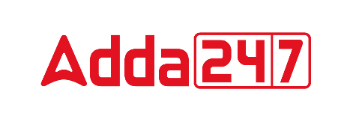

VOCABULARY

1. Append (verb)
Meaning; To add, as an accessory to the principal thing; to annex
Synonyms: adjoin, attach
Antonyms: exclude, remove

2. Excruciating (adjective)
Meaning; Causing great pain or anguish, agonizing
Synonyms: disturbing, irritating
Antonyms: pleasing, soothing

3. Trepidation (noun)
Meaning; A fearful state; a state of concern or hesitation.
Synonyms: apprehension, fear
Antonyms: delight, happiness

4. Poised (verb)
Meaning; Balanced, in position
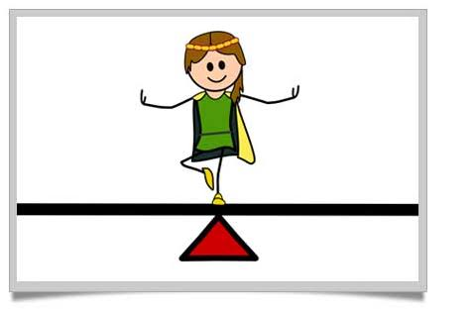
Synonyms: balance
Antonyms: imbalance

5. Wade (verb)
Meaning; to walk through water or something that impedes progress.
Synonyms: paddle
Antonyms: dodge

6. Clinch (verb)
Meaning; To hold firmly; to clench or to make certain; to finalize
Synonyms: finalize, settle
Antonyms: confuse, unsettle

7. Mercurial (adjective)
Meaning; lively, quick-witted or volatile character.
Synonyms: fickle, volatile
Antonyms: fixed, Static

