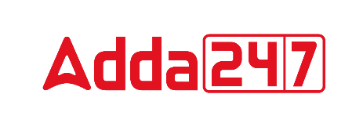
VOCABULARY

1. Excruciating (adjective)
Meaning; Causing great pain or anguish, agonizing
Synonyms: disturbing, irritating
Antonyms: pleasing, soothing

2. Poised (verb)
Meaning; Balanced, in position
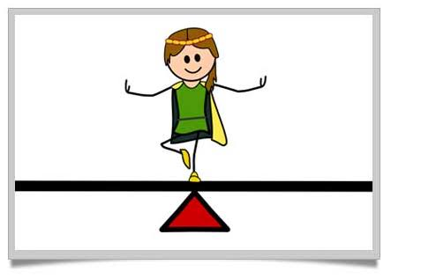
Synonyms: balance
Antonyms: imbalance

3. Iteration (noun)
Meaning; Recital or performance a second time; repetition.
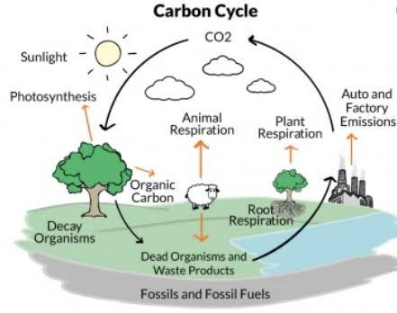
Synonyms: repetition, replay
Antonyms: irregularity, rareness

4. Wade (verb)
Meaning; to walk through water or something that impedes progress.
Synonyms: paddle
Antonyms: dodge

5. Incur (verb)
Meaning; to bring upon oneself or expose oneself
Synonyms: bear, obtain
Antonyms: push, reject

6. Ameliorate (verb)
Meaning; To make better, or improve
Synonyms: alleviate
Antonyms: aggravate

7. Mire (verb)
Meaning; To soil with mud or foul matter.
Synonyms: entangle
Antonyms: release

